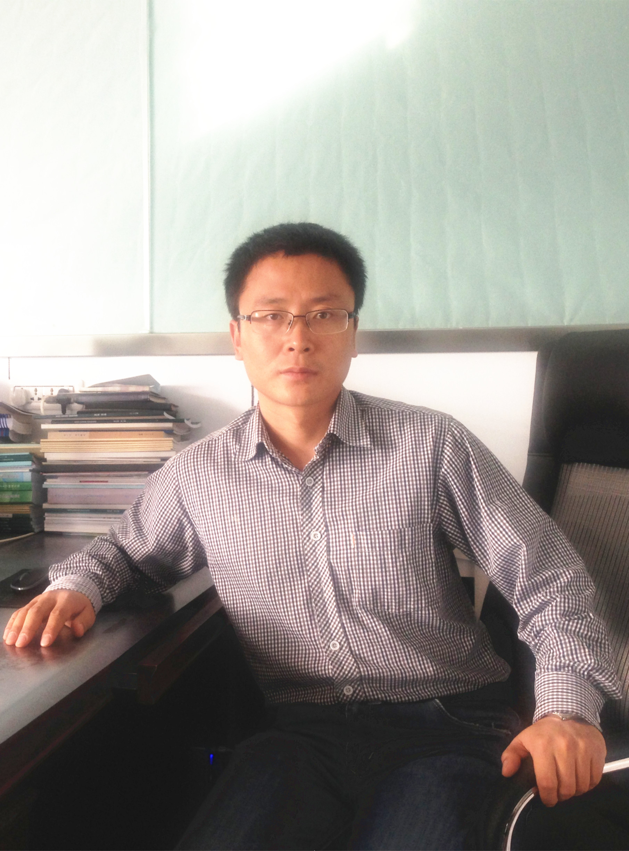
朱明远，男，1980年1月出生，山东潍坊人，副教授，硕士生导师，工业催化硕士学位点负责人，兵团科技创新领军人才。近年来，一直围绕固体催化材料的设计制备及其在多相催化领域的应用开展基础研究工作。迄今主持各类科研项目8项；发表SCI收录论文35篇，第一作者和通讯作者论文20篇（中科院分区1区和2区杂志12篇）；获得兵团科技进步三等奖1项（省部级、排名第一）。
联系方式
• 邮箱：zhumingyuan_shz@sina.com
• 联系电话：18139260208
• 实验室地址：化工中试平台3楼
• 通讯地址：新疆石河子市北四路221号石河子大学化学化工学院
• 邮编：832003
教育经历
• 1999-2003 学士：山东大学化学院，化学专业
• 2003-2009 博士：中国科学院大连化学物理研究所，化学工程专业
工作经历
• 2009-今 副教授：石河子大学化学化工学院化工系
• 2010年9月：遴选为工业催化专业硕士生导师；
讲授课程
[1] 本科生：《催化作用原理》
[2] 研究生：《催化化学》、《工业催化专论》
科研方向
[1] 燃料电池氧还原电催化剂的研究；
[2] 高效乙炔氢氯化反应非汞催化剂的开发
[3] 固载化杂多酸催化剂及其在燃料油深度脱硫中的应用
[4] 低温煤制天然气Ni基催化剂的研究
本课题组热情欢迎对上述工业催化方向感兴趣的优秀学生加盟！
科研项目
[1] 萃取催化法棉粕脱酚及反应机理研究，兵团博士资金，2010JC13, 2010.1-2012.12，主持。(已结题)
[2] 双组元PdM氧还原催化剂的研究，石河子大学高层次人才启动资金，RCZX200936，2010.1-2012.12，主持。（已结题）
[3] 煤焦油氧化脱硫两相催化剂的研究，石河子大学重大科技攻关子课题2，gxjs2010-zdgg02，2010-2012，主持。（已结题）
[4] 基于界面效应设计高效乙炔氢氯化Au基催化剂，国家自然科学基金，21366027， 2014-2017，主持。（在研）
[5] 基于合成气的甲烷化催化剂的制备及工程基础研究，国家自然科学基金-新疆联合基金重点项目，U1203293，2013-2016，联合主持。（在研）
[6] 乙炔氢氯化合成氯乙烯的非汞催化材料与反应工程，科技部973计划项目，2012CB7300， 2012-2016，子课题负责人；（在研）
[7] 中空型HPA@SiO2 催化剂的氧化脱硫反应性能研究，石河子大学杰出青年培育项目，013ZRKXJQ03，2014-2016，主持;(在研)
[8] 乙炔绿色催化体系研究，兵团中青年科技创新领军人才，2015-2017，主持；（在研）
获奖情况
[1] 双组元PdM氧还原电催化剂的研究，2013年兵团科技进步三等奖，第一完成人；
论著一览
1. Mingyuan Zhu, Gongquan Sun*, Huanqiao Li, Lei Cao, Qin Xin. Effect of the Sn(II)/Sn(IV) redox couples on activity of PtSn/C for ethanol electro-oxidation，Chinese Journal of Catalysis, 2008, 29, 765-770.
2. Mingyuan Zhu, Gongquan Sun*, Qin Xin. Effect of alloying degree in PtSn catalyst on the catalytic behavior for ethanol electro-oxidation，Electrochimica Acta, 2009, 54 , 1511-1518.
3. Mingyuan Zhu, Gongquan Sun*, Huanqiao Li, Shiyou Yan, Qin, Xin, Preparation, Structural Characterization and Activity for Ethanol Oxidation of Carbon Supported PtSnIn Catalyst, Energy & Fuels, 2009, 23, 403-407.
4. Huanqiao Li, Gongquan Sun*, Qian Jiang, Mingyuan Zhu, Shiguo Sun, Qin Xin. Preparation and characterization of Pd/C catalyst obtained in NH₃-mediated polyol process, Journal of Power Sources, 2007, 172, 641-649.
5. Huanqiao Li, Gongquan Sun*, Qian Jiang, Mingyuan Zhu, Shiguo Sun, Qin Xin. Synthesis of highly dispersed Pd/C electro-catalyst with high activity for formic acid oxidation, Electrochemistry Communications, 2007, 9, 1410-1415.
6. Qi Wang, Gongquan Sun*, Luhua Jiang, Mingyuan Zhu, Guoxiong Wang, Qin Xin, Shiguo Sun, Qingsong Chen, Yanxia Jiang. Ethanol electrooxidation on carbon supported PtSn catalyst: In situ TRFTIR study, Spectroscopy and spectral analysis, 2008, 28, 47-50.
7. Lihua Kang; Mingyuan Zhu*, Quasi-classical trajectory study of the CD/CH product branching ratios for the C((1)D) + HD reaction, Journal of molecular structure-theochem, 2010, 945, 116-119.
8. Lihua Kang*, Shanzheng Zhang, Mingyuan Zhu, Bin Dai, Effect of vibrational and rotational excitation on the stereodynamics of the C(1D) + H₂ (v, j) CH +H reaction, Can. J. Chem. 2011, 89: 1283-1288.
9. Haiyang Zhang, Bin Dai*, Xugen Wang, Longlong Xu, Mingyuan Zhu, Hydrochlorination of acetylene to vinyl chloride monomer over bimetallic Au-La/SAC catalysts, Journal of Industrial and Engineering Chemistry 2012, 18: 49-54.
10. Lingyu Zhao, Zhong Wei* , Mingyuan Zhu, Bin Dai, Catalytic performance of a Ti added Pd/SiO₂ catalyst for acetylene hydrogenation, Journal of Industrial and Engineering Chemistry, 2012,18, 45-48.
11. Shihong Dong, Mingyuan Zhu*, Bin Dai*, Synthesis, Characterization and Application of ZS/HMS Catalyst in the Esterification of Gossypol，Green and Sustainable Chemistry, 2012, 2, 8-13。
12. Mingyuan Zhu, Xiaoling Gao, Guangqin Luo, Bin Dai*, A novel method for synthesis of phosphomolybdic acid-modified Pd/C catalysts for oxygen reduction reaction， Journal of Power Sources，225，2013，27-33.
13. Shihong Dong, Mingyuan Zhu*, Bin Dai*, Synthesis of Alumina-Containing Hexagonal Mesopoporous Silica and its application in the Adsorption of Gossypol. Asian Journal of Chemistry, 25, 2013, 525-528.
14. Mingyuan Zhu, Lihua Kang*, Yan Su, Shanzheng Zhang, Bin Dai, MCl_{x}(M=Hg, Au, Ru; x=2,3) catalyzed hydrochlorination of acetylene: a density functional theory study, Canadian Journal of Chemistry, 2013, 91(2): 120-125.
15. Ling Tang, Guangqing Luo, Lihua. Kang*, Mingyuan Zhu*, Bin Dai, A novel [Bmim]PW/HMS catalyst with high catalytic performance for the oxidative desulfurization process, Korean Journal of Chemical Engineering, 2013, 30(2), 314-320.
16. Ling Tang, Guangqin Luo, Mingyuan Zhu*, Lihua Kang, Bin Dai, Preparation, characterization and catalytic performance of HPW-TUD-1 catalyst on oxidative desulfurization, Journal of Industrial and Engineering Chemistry, 19, 2013, 620-626.
17. Xiaoyan Li, Mingyuan Zhu*, Bin Dai *, AuCl₃ on polypyrrole-modified carbon nanotubes as acetylene hydrochlorination catalysts, Applied Catalysis B, 142-143, 2013，234-240.
18. Lei Shi, Zhong Wei, Mingyuan Zhu *, Jun Yuan*, Bin Dai, Polymer Brushes Supported Polyoxometalate Catalyst for Ultra-Deep Desulfurization of Diesel, Asian Journal of Chemistry, 25, 2013, 6888-6892.
19. Guangqin Luo, Lihua Kang, Mingyuan Zhu *, Bin Dai, Highly active phosphotungstic acid immobilized on amino functionalized MCM-41 for the oxidesulfurization of dibenzothiophene，Fuel Processing Technology, 118, 2014, 2027.
20. Xiaoyan Li, Yang Wang, Lihua Kang, Mingyuan Zhu *, Bin Dai *, A novel, non-metallic graphitic carbon nitride catalyst for acetylene hydrochlorination, Journal of Catalysis, 311, 2014, 288-294.
21. Chaofeng Huang, Mingyuan Zhu *, Lihua Kang, Xiaoyan Li, Bin Dai *, Active carbon supported TiO₂–AuCl₃/AC catalyst with excellent stability for acetylene hydrochlorination reaction, Chemical Engineering Journal, 242, 2014, 69-75.
22. Mingyuan Zhu, Guangqin Luo, Lihua Kang *, Bin Dai *, A novel catalyst by immobilizing phosphotungstic acid on polymer brushes and its application in oxidative desulfurization,RSC Advances, 2014, 4 (32), 16769 – 16776.
23. Chaofeng Huang, Mingyuan Zhu *, Lihua Kang, Bin Dai *, A novel high-stability Au(III)/Schiff-based catalyst for acetylene hydrochlorination reaction, Catalysis Communications, 2014, 54(5), 61-65.
24. Yu, Feng; Zhang, Lili; Zhu, Mingyuan; An, Yongxin; Xia, Lili; Wang, Xugen; Dai, Bin，Overwhelming microwave irradiation assisted synthesis of olivine-structured LiMPO4 (M=Fe, Mn, Co and Ni) for Li-ion batteries，Nano Energy, 2014, 3, 64-79.
25. Wang, Yang; Zhu, Mingyuan; Kang, Lihua; Dai, Bin，Density functional theory study of side-chain alkylation of toluene with formaldehyde over alkali-exchanged zeolite，Microporous and Mesoporous Materials， 2014， 196， 129-135.
26. Zhang, Haiyang; Dai, Bin; Li, Wei; Wang, Xugen; Zhang, Jinli; Zhu, Mingyuan; Gu, Junjie, Non-mercury catalytic acetylene hydrochlorination over spherical activated-carbon-supported Au-Co(III)-Cu(II) catalysts, Journal of Catalysis, 2014, 316, 141-148.
27. Wang, Yang; Zhu, Mingyuan; Kang, Lihua; Dai, Bin, Neutral Au-n (n=3-10) clusters catalyze acetylene hydrochlorination: a density functional theory study, RSC Advances, 2014, 4(72), 38466-38473.
28. Yu, Feng; Zhang, Lili; Li, Yingchun; An, Yongxin; Zhu, Mingyuan; Dai, Bin, Mechanism studies of LiFePO4 cathode material: lithiation/delithiation process, electrochemical modification and synthetic reaction, RSC Advances, 2014, 4(97), 54576-54702
29. Weijie Han, Xugen Wang, Mingyuan Zhu, Haiyang Zhang, Kun Chen, Qinqin Wang, Xiaoyan Li, Bin Dai*，Melamine modification of spherical activated carbon and its effects on acetylene hydrochlorination， Journal of Wuhan University of Technology-Mater. Sci. Ed. 2014, 29(6), 1147-1151.
30. Chunli Zhang, Lihua Kang, Mingyuan Zhu*, Bin Dai *, Nitrogen-doped active carbon as a metal-free catalyst for acetylene hydrochlorination, RSC Advances, 2015, 5, 7461-7468.
31. Kun Chen, Lihua Kang, Mingyuan Zhu *，Bin Dai *，Mesoporous carbon with controllable pore sizes as a support of the AuCl₃ catalyst for acetylene hydrochlorination， Catal. Sci. Technol., 2015, 5, 1035-1040.
32. Yanxin Wang, Yan, Su Yan, Mingyuan Zhu, Kang, Lihua Kang *, Ni cluster nucleation and growth on the anatase TiO2(101) surface: A density functional theory study , RSC Advances, 2015, 5(21), 16582-16591,
33. Gang Wang *, Jun Peng, Lili Zhang, Jun Zhang, Bin Dai *, Mingyuan Zhu, Lili Xia, Feng Yu *, Two-dimensional SnS₂@PANI nanoplates with high capacity and excellent stability for lithium-ion batteries, J. Mater. Chem. A, 2015, In press, DOI: 10.1039/C4TA06384H.
34. Bin Dai, XiaoyanLi, JinliZhang, FengYu, MingyuanZhu *, Chemical Engineering Science, 2015, In press, DOI: 10.1016/j.ces.2014.12.017.
35. Yunfeng Zhu, Mingyuan Zhu,*, Lihua Kang, Feng Yu , Bin Dai, Phosphotungstic Acid Supported on Mesoporous Graphitic Carbon Nitride as Catalyst for Oxidative Desulfurization of Fuel, Industrial & Engineering Chemistry Research, 2015, In press, DOI: 10.1021/ie504372p.

